**Student Management System Project Phase 1 – Report**

# Description of your proposed platform

The proposed web platform is a role-based course management system designed to serve three types of users: students, instructors, and administrators. Each user type is granted specific functionalities based on their role, with the goal of streamlining the course registration, learning, and administration processes in an academic environment.

Student Functionality

Upon successful login or registration, student users are directed to the main page, which displays a list of all available courses by default. Students can refine their search using filters based on course name (e.g., JavaScript, OOP) or course category (e.g., Databases, Programming). Once a course is selected, the student is directed to the registration page, where multiple class sections (taught by different instructors) for the selected course are displayed.

Students are allowed to register for a course only if three conditions are met:

1. They have successfully completed all prerequisite courses and if the perquisite is in the in progress course as we considered the date after the drop course which means that the student has to successfully finish the course.
2. The course is currently open for registration.
3. The course has available seats

If the student meets these conditions and the selected class still has available slots, registration proceeds. A confirmation message is displayed upon successful registration, and course data is updated accordingly. However, the registration remains pending until officially validated by an administrator.

The platform also features a navigation bar, through which students can access their profile page. The profile page presents a comprehensive overview of the student’s learning path, including:

* Courses completed successfully (with corresponding grades),
* Courses currently in progress,
* Courses pending approval (i.e., registration submitted but not yet validated or started).
* Courses remaining

Instructor Functionality

After logging in, instructors are redirected to their main page, which categorizes their assigned classes into three sections: In Progress, Pending, and Completed.

* In Progress: These are active classes where the instructor can click to access the grades page. In this page, the instructor can view the list of enrolled students and is allowed to input and submit their grades for record-keeping.
* Pending: These are classes that have not yet been validated by the administrator. Although the instructor can access the grades page for pending classes, the system will not allow grade submission until the class is officially validated and moved to the "In Progress" category.
* Completed: This section includes all courses that have been finished after the instructor submitted the final grades for students in the "In Progress" classes.

This structured view helps instructors clearly distinguish between the status of their classes and manage their responsibilities efficiently.

Administrator Functionality

Administrators gain access to a centralized dashboard after login, which displays all Pending courses and classes. These are courses or class sections that have not yet been validated. Administrators have the authority to officially validate them, upon which their status changes to In Progress, allowing them to begin.

If an administrator chooses to unvalidate a course or class, it is effectively deleted from the system as a pending item. This mechanism ensures that only courses with sufficient student interest and appropriate setup proceed to the learning phase. Additionally, administrators have the capability to create new courses and assign instructors to specific class sections, enabling full control over academic offerings and scheduling.

**Sketch:**

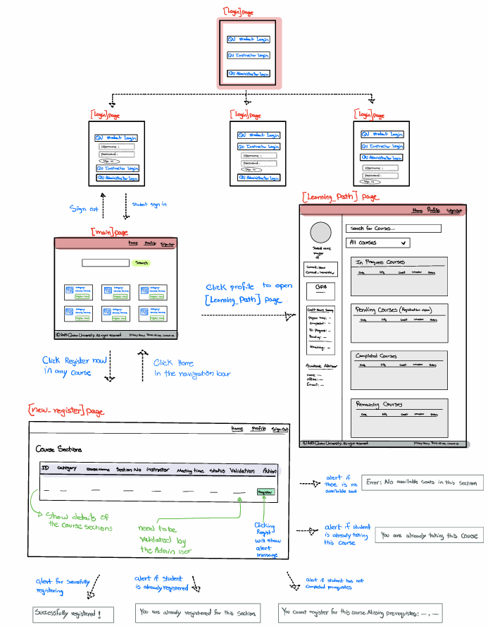

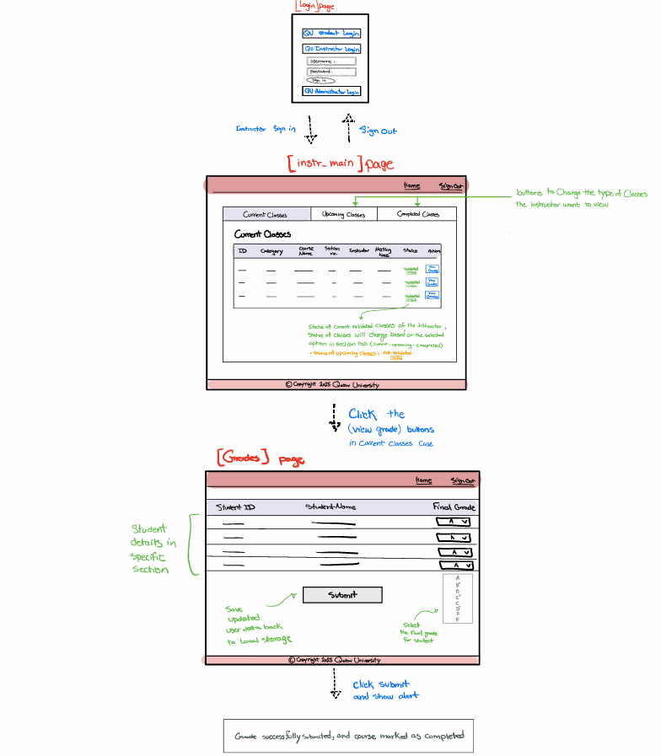

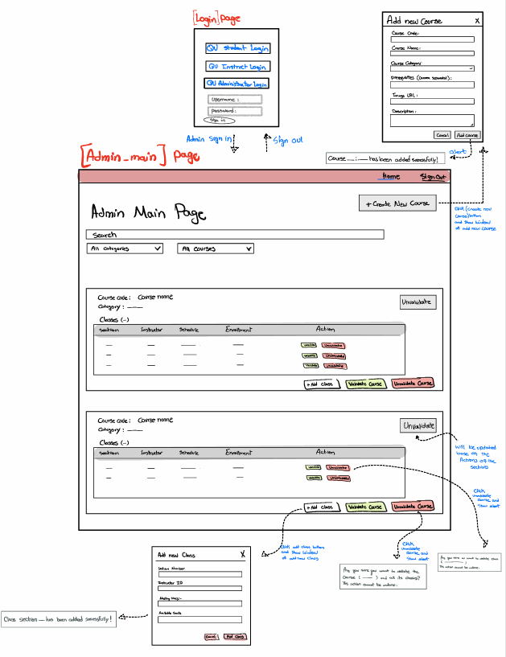

# Application Design

# Use case diagram

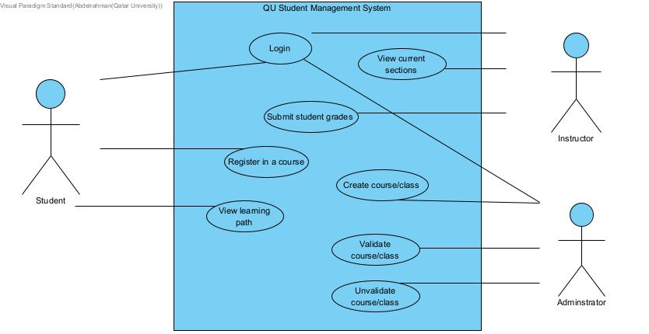

# Entities class diagram

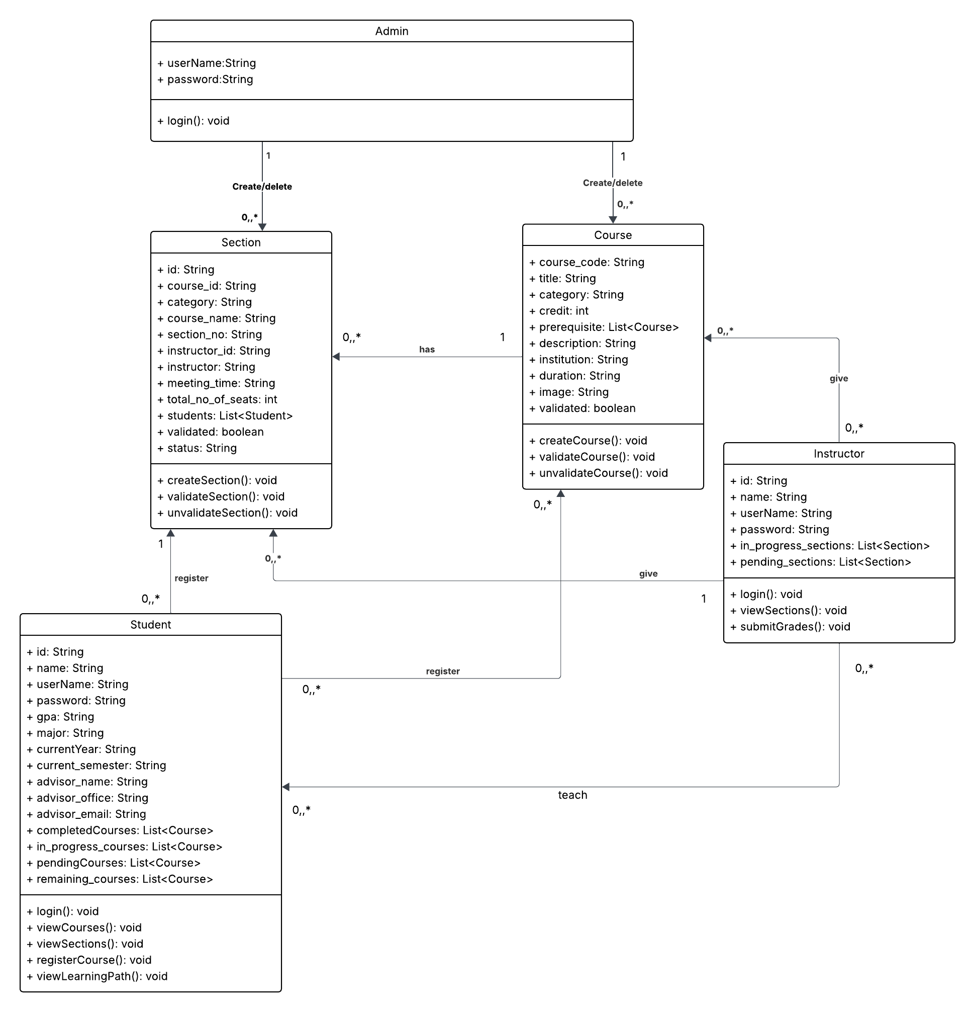

# Web API class

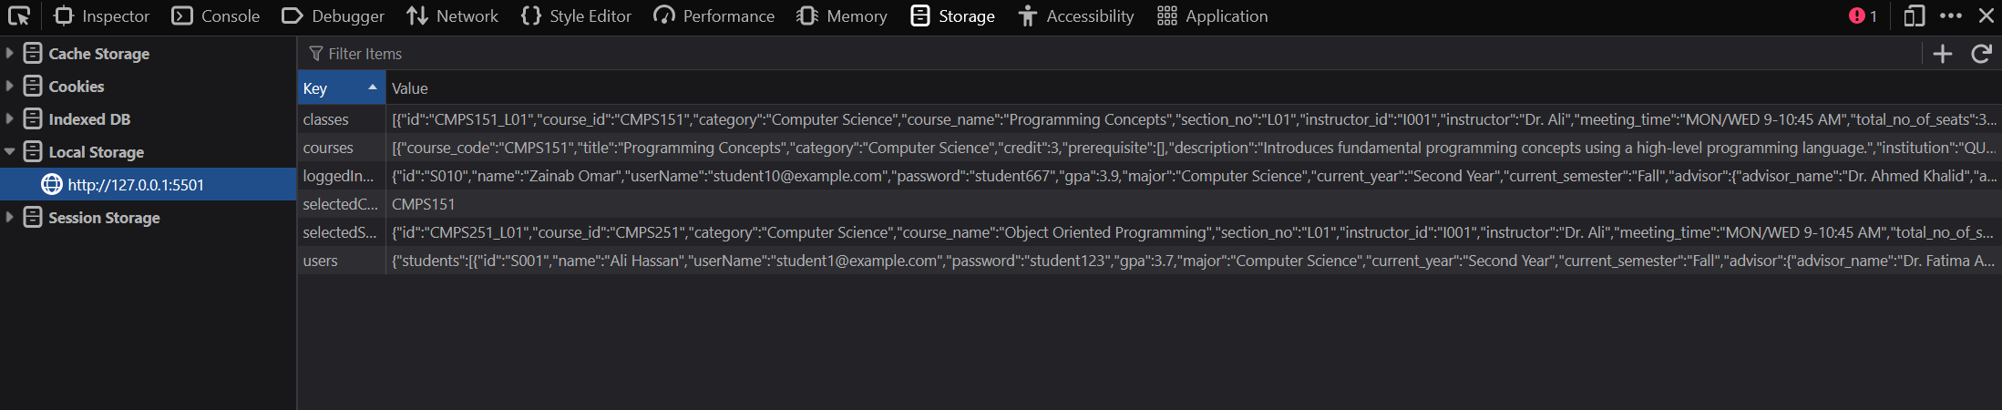

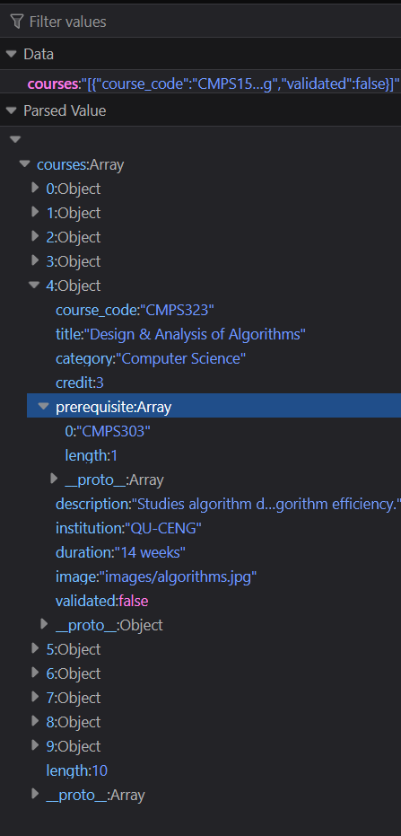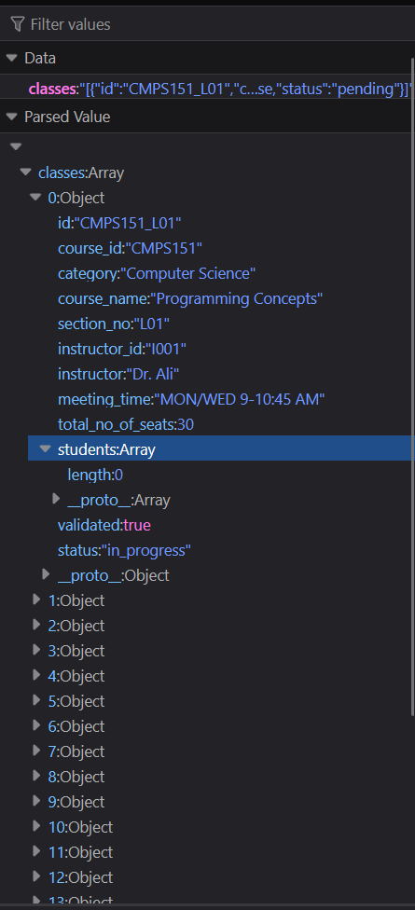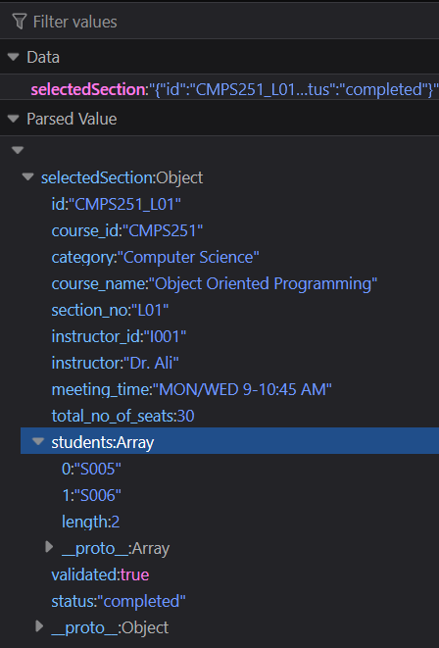

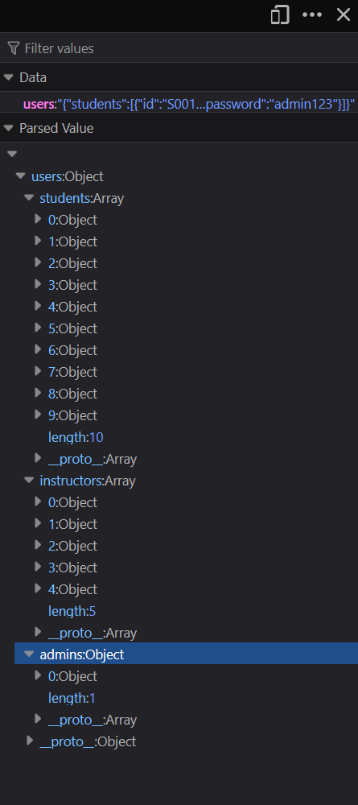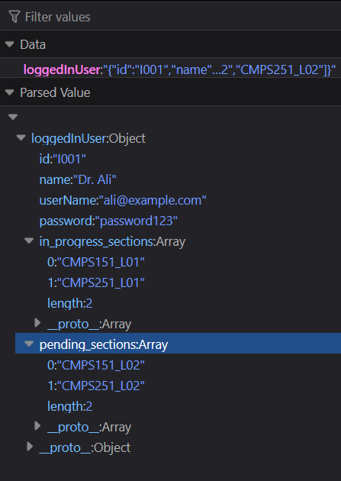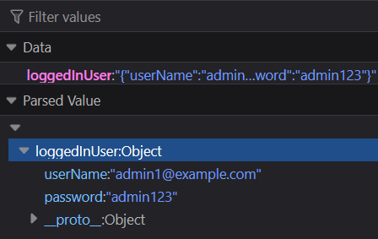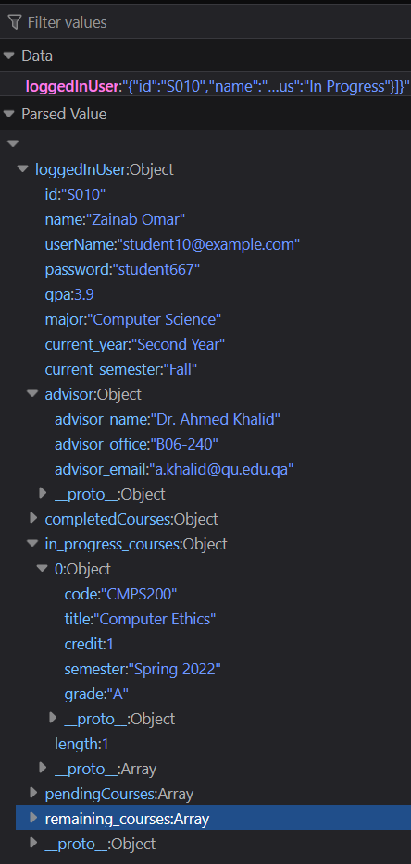

# Implementation

# Implemented use-cases

Use Case 1: Login

Use Case 2: Search and display available courses

Use Case 3: Register in a course

Use Case 4: View their learning path

Use Case 5: Creating / validating courses and classes

Use Case 6: Grades submission

# Unimplemented use-cases and not functioning parts

In use case (5): Only pending courses and classes can be validated and vice versa assuming that in-progress courses and classes are already validated and can not be deleted.

# Testing

# Use case 1





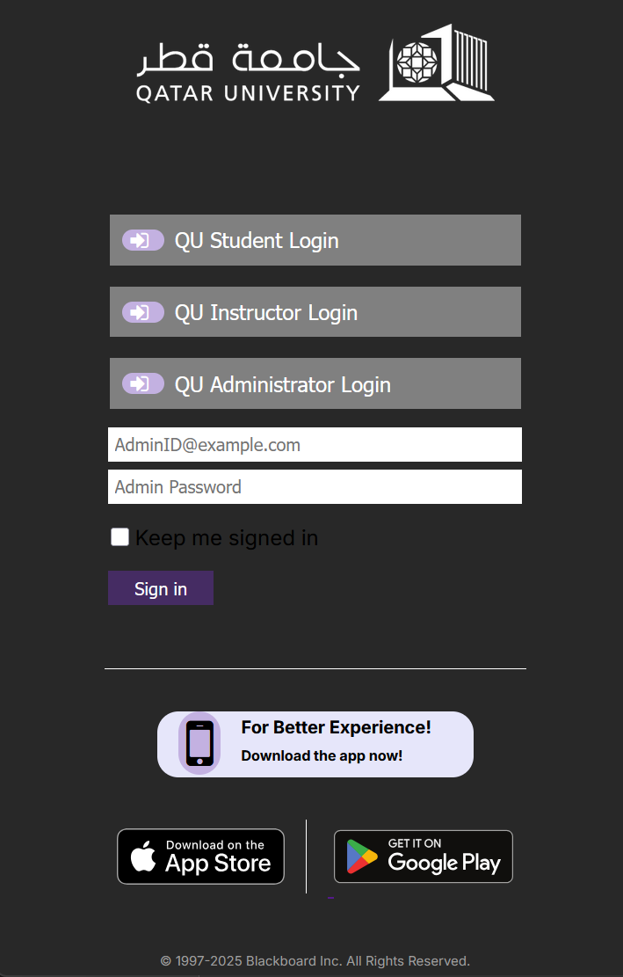

# Use case 2



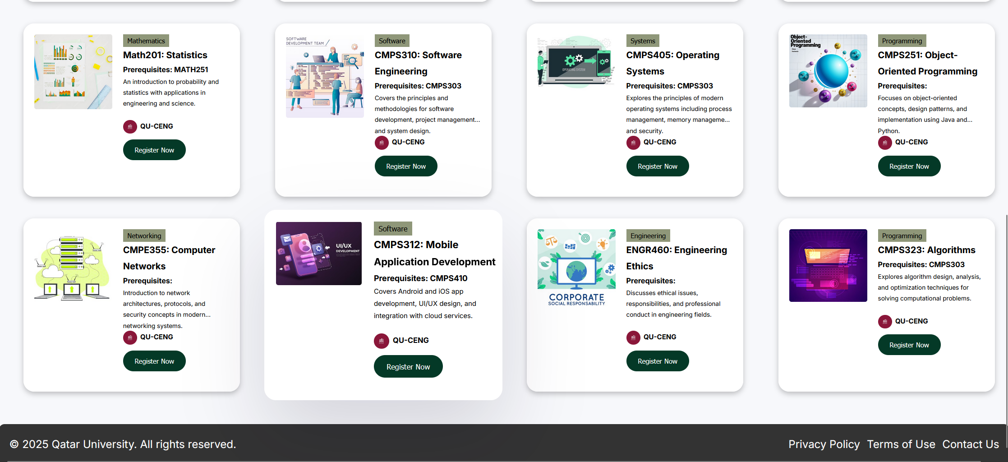

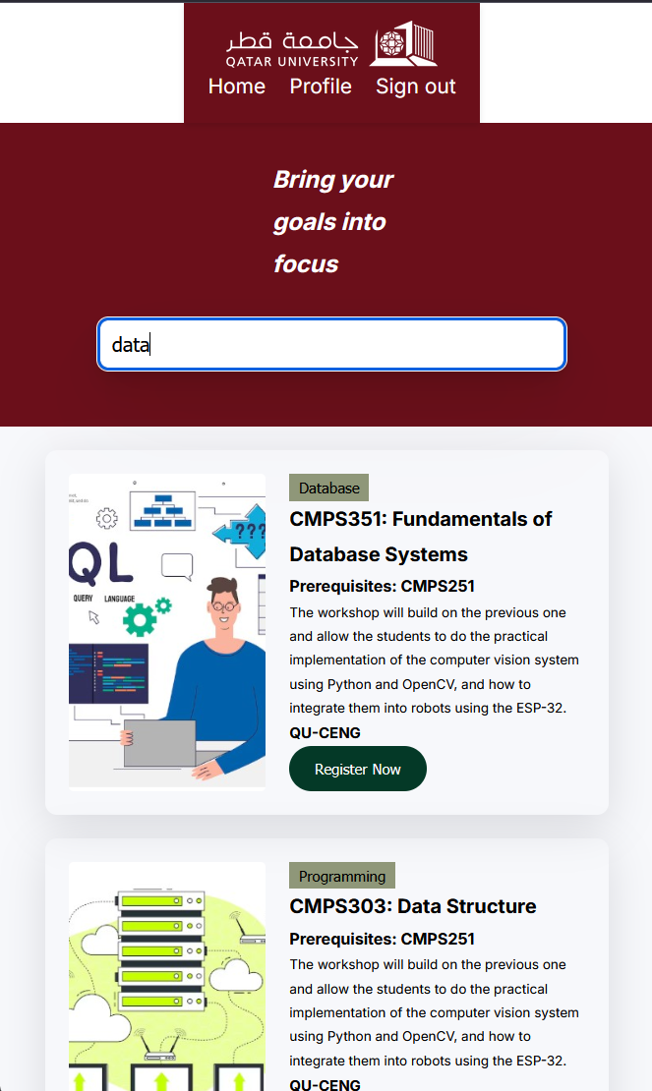

# Use case 3

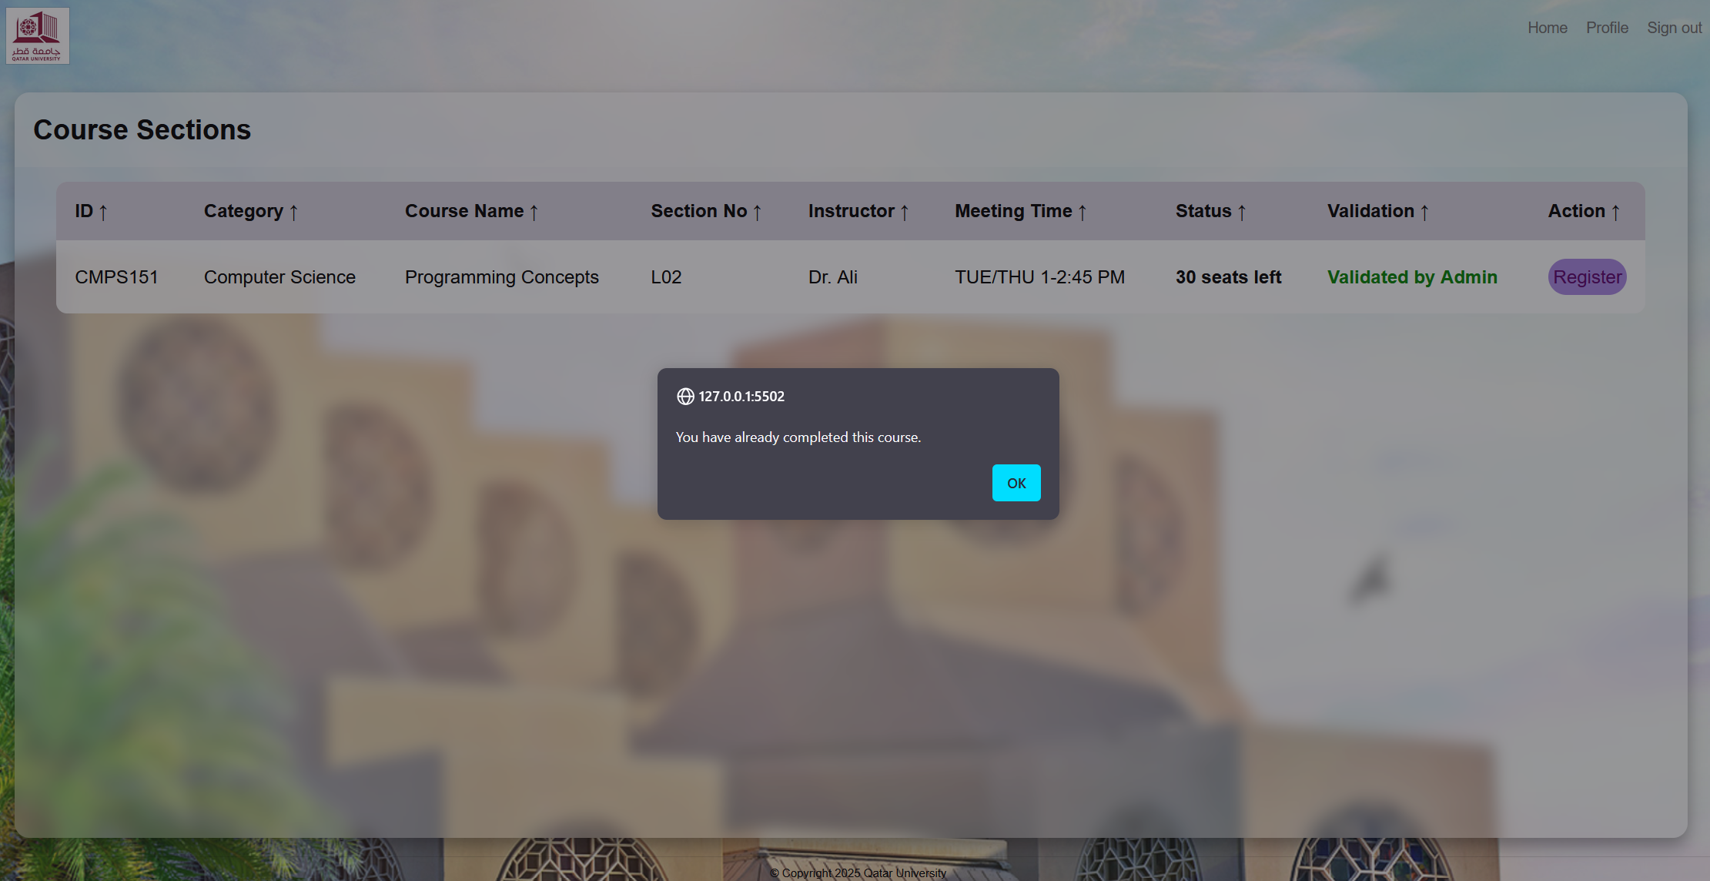

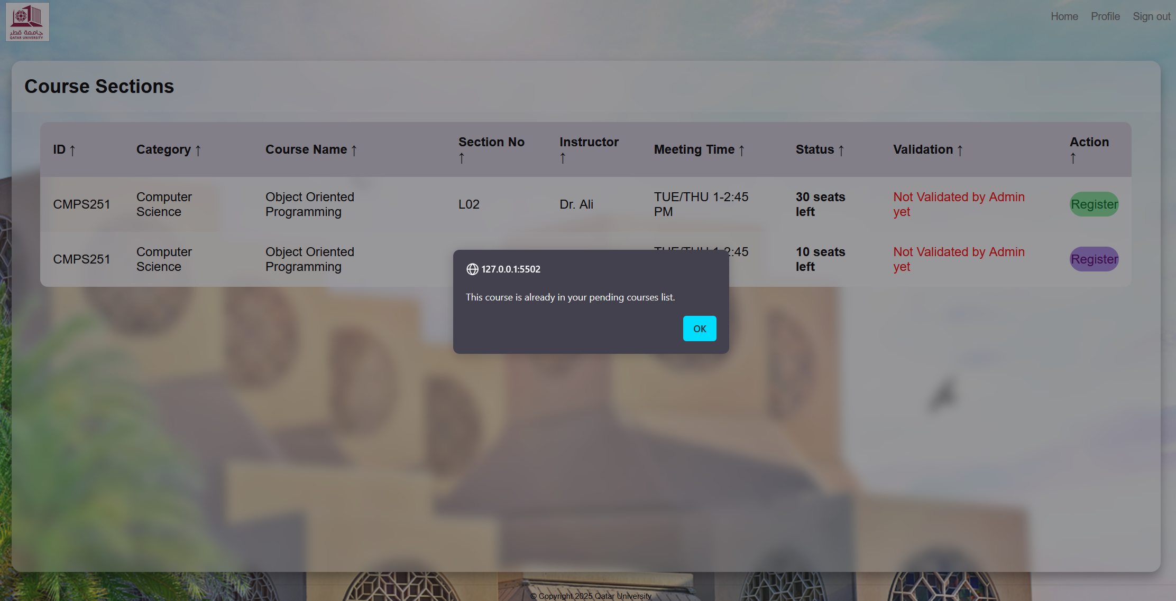

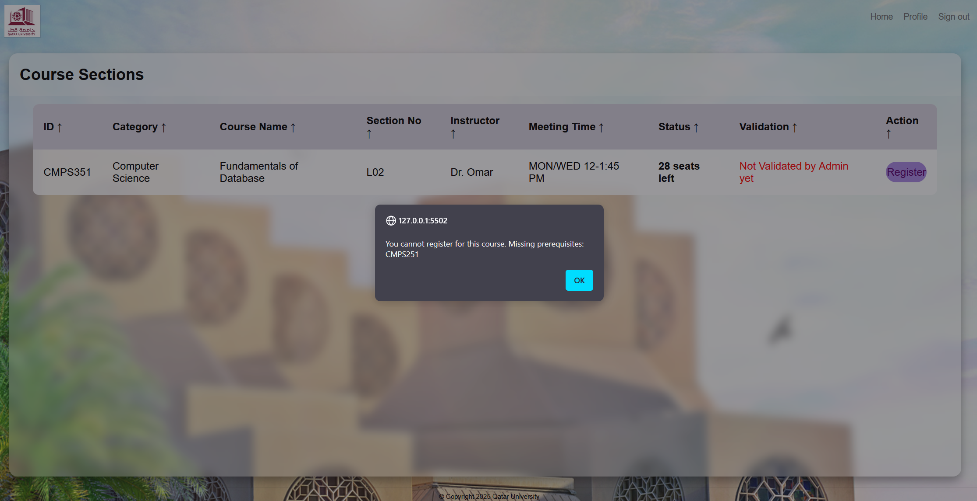

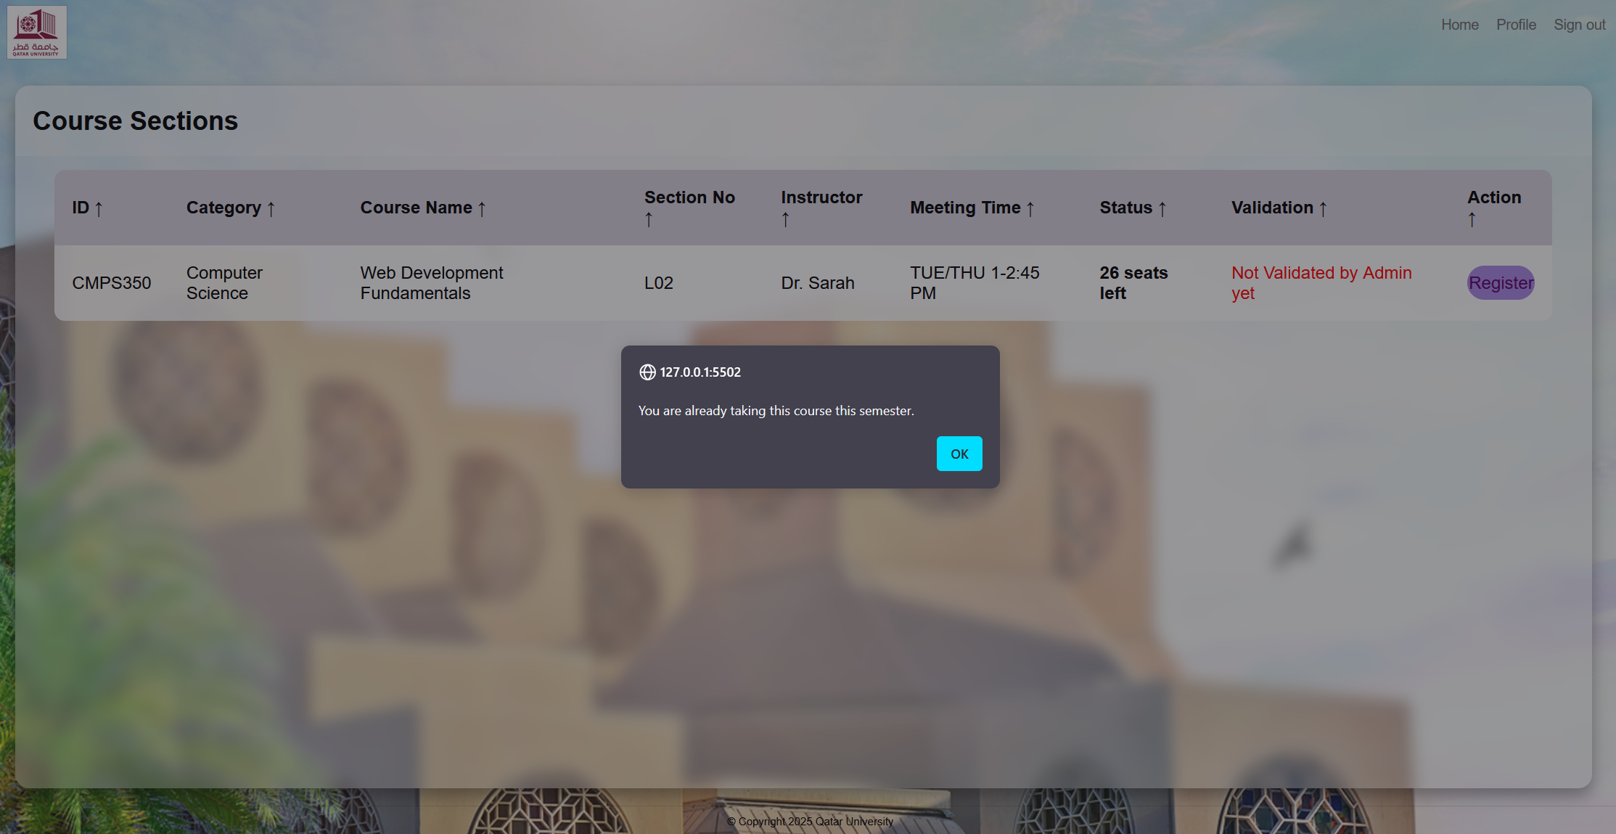

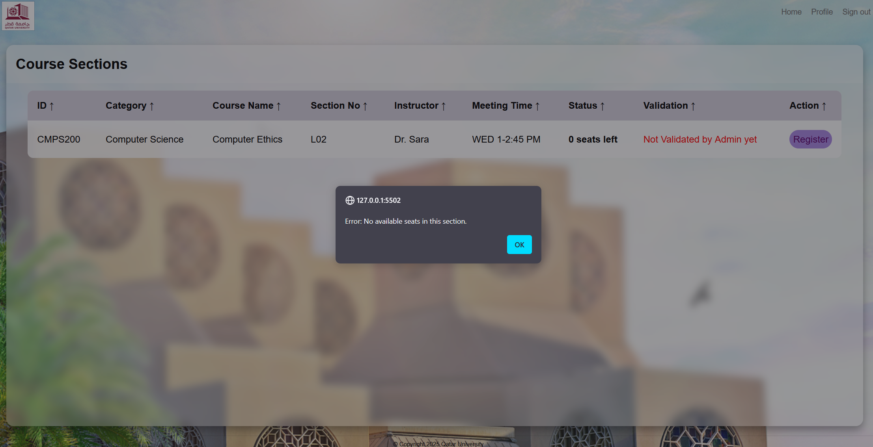

# Use case 4

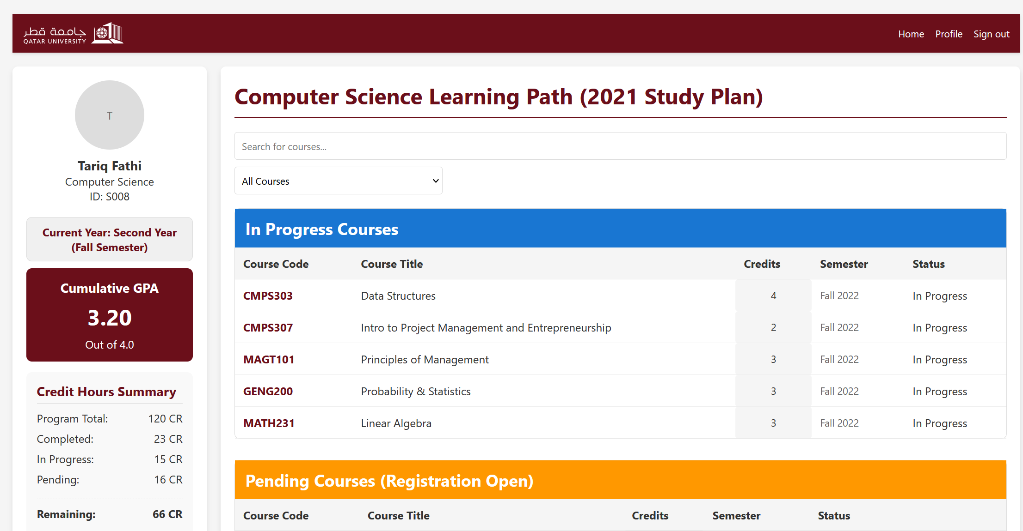

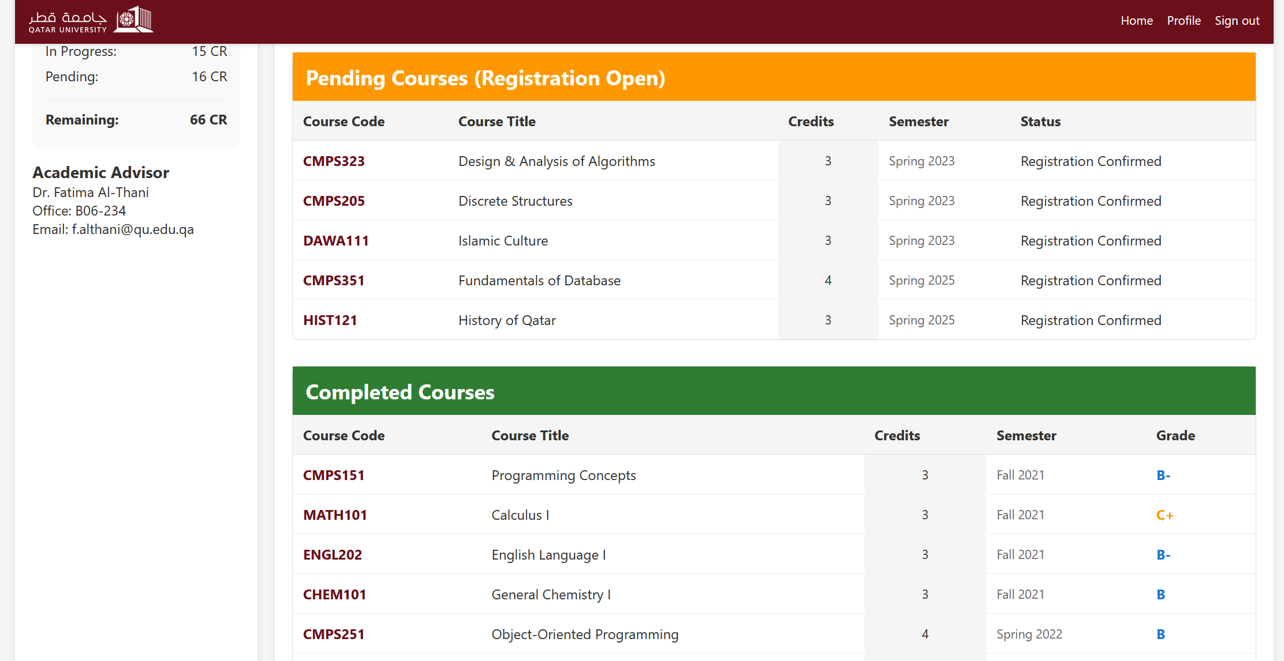

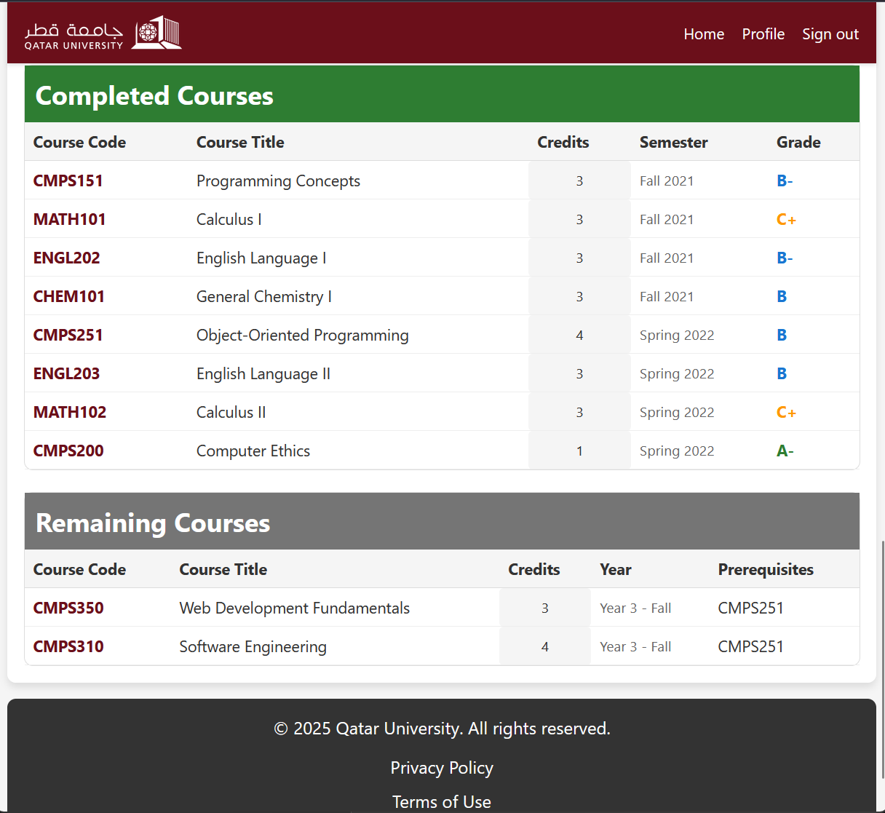

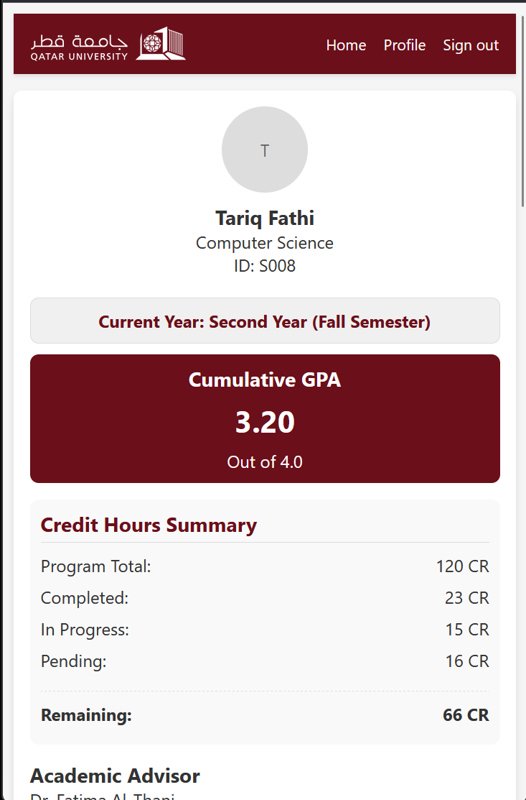

# Use case 5

1. Desktop view

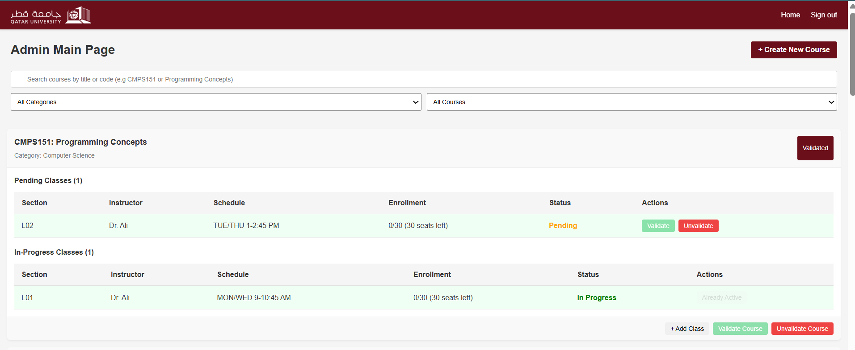

1. Mobile view

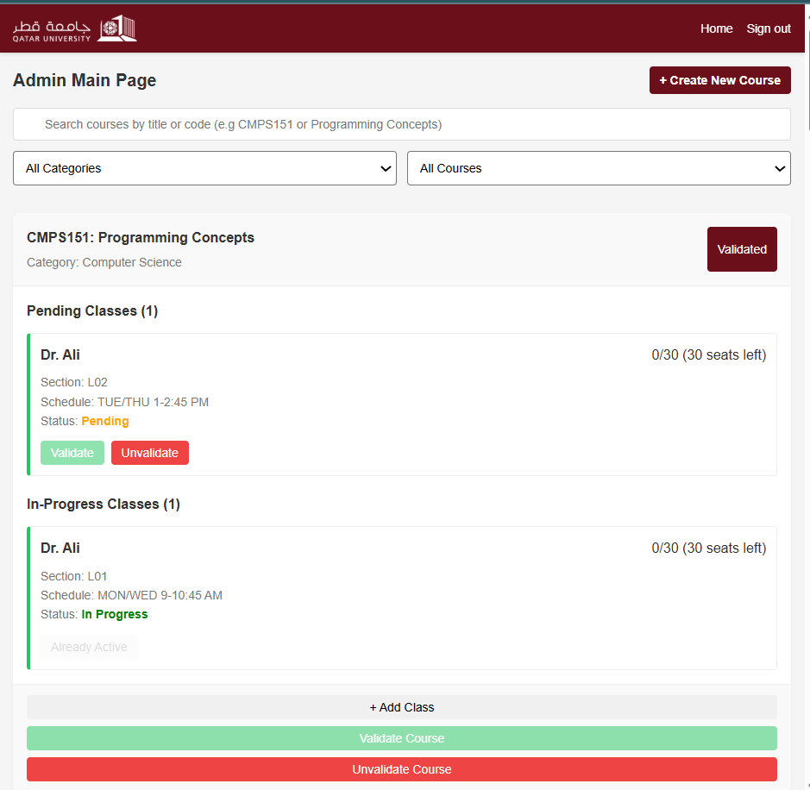

1. Add course

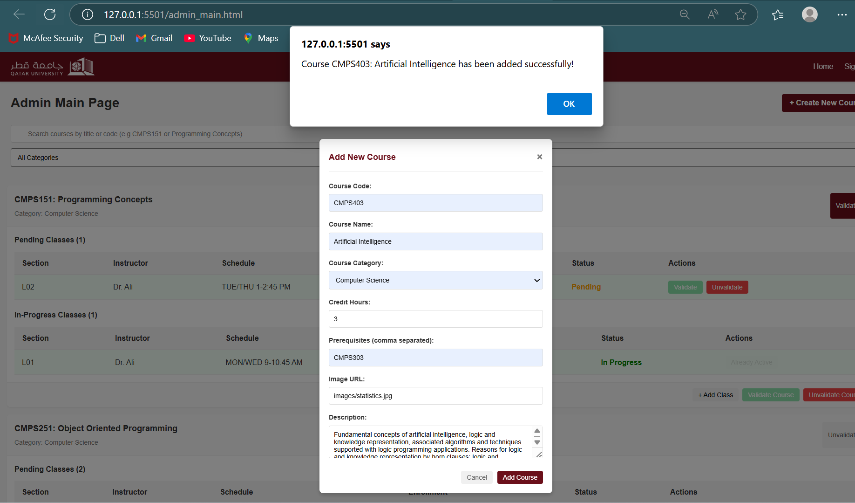

1. Add class to a course

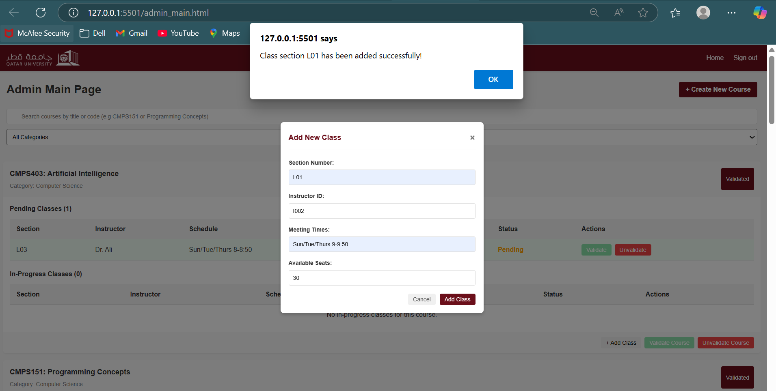

1. Validate course/ section

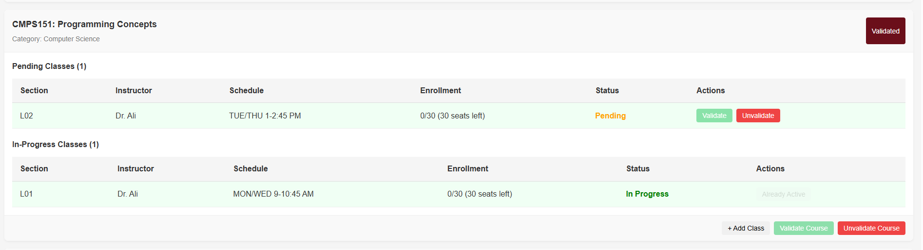

1. Invalidate section

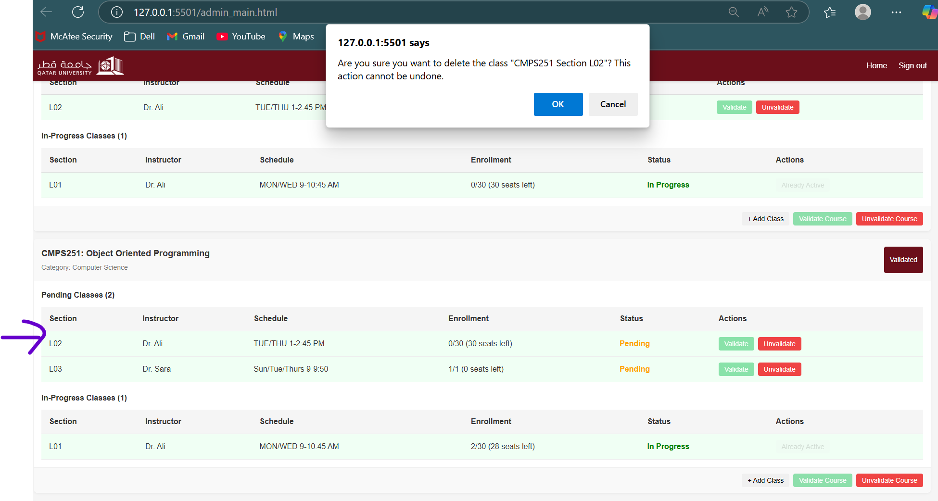

1. Invalidate course

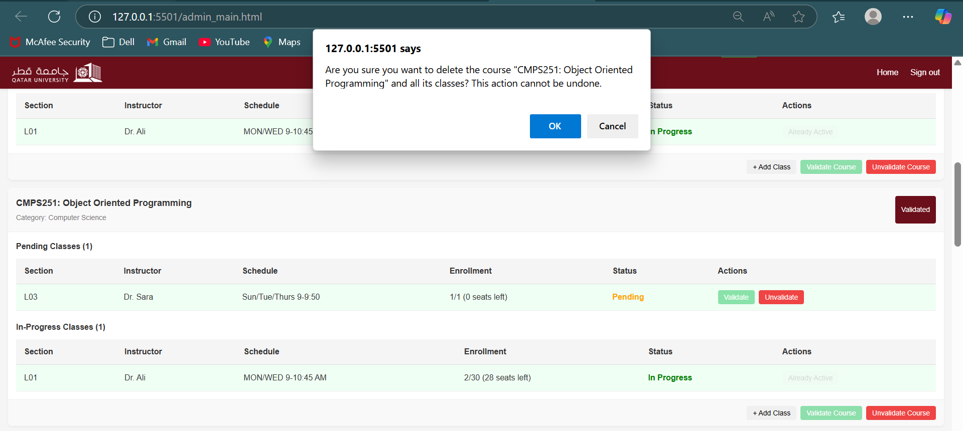

# Use case 6

